Project Report on
Medical Store Management System

Course Title : Project Work
Course Code : CSE-327

Submitted by:

Md. Zahidur Rahman
ID: 1108027
Session :2012-13

Supervisor:
Partha Chakraborty
Lecturer,
Department of CSE
Comilla University

COMILLA UNIVERSITY


Date of Submission: 29 January 2018

CERTIFICATE
This is to certified that the project report “Medical Store Management System” is the outstanding work of “ Md. Zahidur Rahman” who carried out the project work under my supervision.
.

----------------------------
Signature of Supervisor
Partha Chakraborty
Lecturer
Department of CSE
Comilla University

ACKNOWLEDGEMENT

I here, feel very grateful presenting this project report on “Medical Store Management System. It was very nice experience while working on this project. I feel very fortunate here to have support of number of key individuals during this project report. Here, I take chance to thank them all for helping us all the way during the study report.

ABSTRACT

Medical Store Management System deals with the maintenance of a medical store. In this project we are going to design and manage all medical medicines and data on software, the software updates with all types of medicine. In the software a necessary programming is done, in Java Swing. The main focus is on the billing area. System is so designed as to ease the work load of medical shop professionals. The main feature includes invoicing, inventory and stock control, accounting, client and vendor management. This system helps us to track all products of medical shop moreover it’s a medical shop accounting software. As this is generic software it can be used by a wide variety of outlets (Retailers and Wholesalers) to automate the process of manually maintaining the records related to the subject of maintain the stock and cash and flows.

.

INDEX

ACKNOWLEDGEMENT....................................................................................................................Ⅲ
ABSTRACT.........................................................................................................................................Ⅳ
LIST OF CONTENTS..........................................................................................................................Ⅴ
LIST OF FIGURES..............................................................................................................................Ⅵ

LIST OF CONTENTS

Chapter-1: Introduction
  - Purpose of the system.....................................................................................................7
  - Existing System.............................................................................................................7
  - Silent Features................................................................................................................8
  - General Features............................................................................................................8

Chapter-2: Background of the Study ………………………………………................……..9

Chapter-3: Methodology

3.1 AnalysisModel..............................................................................................................10
3.2 FeasibilityStudy............................................................................................................10
2.3 Software requirements..................................................................................................11
3.4 DFD..............................................................................................................................13
3.5 E-R Diagarm.................................................................................................................14

Chapter-4: Implementation & Testing
4.1 Cover page Form..........................................................................................................15
4.2 Select Form...................................................................................................................16
4.2.1.1 Login Form...................................................................................................................17
4.2.1.2 Menu Form ………………………………………………………...…………….......18
4.2.1.3 Add Category Form......................................................................................................19
4.2.1.4 Update Category Form.................................................................................................20
4.2.1.5 Delete Form..................................................................................................................21
4.2.1.6 Add Product Form........................................................................................................22
4.2.1.7 Update Product Form...................................................................................................23
4.2.1.8 Delete Product Form....................................................................................................24
4.2.1.9 Product List Form........................................................................................................25
4.2.1.10 Order List Form.........................................................................................................26
4.2.2.1 User Login Form…………………………………………………….………….....…27
4.2.2.2 Signup Form……………………………………………………………….......……28
4.2.2.3 Order Form………………………………………………………………….......……29

Chapter-5: Comparison…………………………………………………………….30

Chapter-6: Conclusion and Future work…………………………………………31

List of References.........................................................................................................32

LIST OF FIGURES

Fig No. | Figure Name | Page
3.1 | DFD | 13
3.2 | E-R Diagram | 14
4.1 | Cover page Form | 15
4.2 | Select Form | 16
4.3 | Login Form | 17
4.4 | Error message box | 17
4.5 | Menu Form | 18
4.6 | Add Category Form | 19
4.8 | Update Category Form | 20
4.9 | Delete Category Form | 21
4.10 | Add Product Form | 22
4.11 | Update Product Form | 23
4.12 | Delete Product Form | 24
4.13 | Product List Form | 25
4.14 | Order List Form | 26
4.15 | Login Form | 27
4.16 | Signup Form | 28
4.17 | Order Form | 29

CHAPTER ONE
Introduction

1.1 Purpose of the system
Medical Store Management System is a replacement for existing manual billing system currently in use at almost all shop.

- To benefit my own shop
- Cost Reduction
- Getting rid of cluttered experience
- More Automation
- Competitive
- Employee Retention

1.2 Existing System
The existing system uses paper based system to keep information which is slow and old process .This manual system is highly labor-intensive to operate. The system requires continuous monitoring. This system relies heavily on the actions of people which increase the possibility of human-made error.

1.3 Silent Features
- Menu Driven, Key Board and Mouse Navigation.
- Paperless Practice.
- Improve Efficiency, Productivity.
- Cost Effective Solutions.
- Graphical User Interface with Context Sensitive Help.
- No Special Training Needed For Using The System.

1.4 General Features

- Portable
- Easy to Learn
- Well documented
- Automated
- Flexible

CHAPTER TWO
Background of the Study

2 Background of the Study

In this project I am going to design and manage all medical medicines and data on software. Software updates all types of medicine those are highly demanded. The main focus of software is on the billing area. This kind of project is previously done by other persons and I am also tried to give my best in this work. Hopefully, in future I can do better than this.

System is so designed as to ease the work load of medical shop professionals. The main feature includes invoicing, inventory and stock control, accounting, client and vendor management.

CHAPTER THREE
Methodology
3.1 Analysis Model
Here, we follow Water Fall model. First of all the feasibility study is done. Once that part is over the requirement analysis and project planning begins. The design starts after the requirement analysis is complete and the coding begins after the design is complete. Once the programming is completed, the testing is done. In this model the sequence of activities performed in a software development project are: -
• Feasibility study
• Requirement Analysis
• Project Planning
• System design
• Detail design
• Coding
• Unit testing
• System integration & testing

3.2 Feasibility study
Preliminary investigation examine project feasibility, the likelihood the system will be useful to the organization. The main objective of the feasibility study is to test the Technical, Operational and Economical feasibility for adding new modules and debugging old running system. All system is feasible if they are unlimited resources and infinite time. There are aspects in the feasibility study portion of the preliminary investigation:
• Technical Feasibility
• Economical Feasibility
• Behavioral Feasibility

3.2.1 Technical Feasibility
Technical Feasibility centers on the existing computer system hardware, software, etc. and to some extent how it can support the proposed addition. Since the project is designed with Eclipse with Java as Front end and MySQL Server as Back end, it is easy to install in all the systems wherever needed. It is more efficient, easy and user-friendly to understand by almost everyone. Huge amount of data can be handled efficiently using MySQL Server as back end. Hence this project has good technical feasibility.

3.2.2 Economical Feasibility
Economic Feasibility is mainly concerned with the cost incurred in the implementation of the software. Since this project is developed using JAVA with Eclipse and MySQL which is more commonly available and even the cost involved in the installation process is not high.
The system is also time effective because the calculations are automated. The result obtained contains minimum errors and are highly accurate as the data is required.

3.2.3 Behavioral Feasibility

The system working is quite easy to use and learn due to its simple but attractive interface. User requires no special training for operating the system.[1]

3.3 Software requirements
Operating System : - Microsoft Windows 7,8,10
Data Base Server: MySQL
Front-End: Eclipse, Java Swing, JDK
Back-End: MySQL

3.3.1 Eclipse IDE

Eclipse is an integrated development environment (IDE). It contains a base workspace and an extensible plug-in system for customizing the environment. Written mostly in Java, Eclipse can be used to develop applications. By means of various plug-ins, Eclipse may also be used to develop applications in other programming languages. [2]

3.3.2 JAVA

Java is a programming language and computing platform first released by Sun Microsystem in1995. There are lots of applications and websites that will not work unless you have java installed, and more are created every day. Java is fast, secure, and reliable. From laptops to datacenters, game consoles to scientific supercomputers, cell phones to the Internet, Java is everywhere. [3]

3.3.3 MySQL

MySQL is a free and open source cross-platform that provides MySQL database, and interpreters for scripts written in programming languages. 12

3.3.4 Java Swing
Java Swing is a GUI widget toolkit for Java. It is part of Oracle's Java Foundation Classes (JFC) – an API for providing a graphical user interface (GUI) for Java programs. It has more powerful and flexible components than AWT. In addition to familiar components such as buttons, check boxes and labels, Swing provides several advanced components such as tabbed panel, scroll panes, trees, tables, and lists.

3.3.5 JDK

The Java Development Kit (JDK) is an implementation of either one of the Java Platform, Standard Edition; Java Platform, Enterprise Edition or Java Platform, Micro Edition platforms^{[1]} released by Oracle Corporation in the form of a binary product aimed at Java developers on Solaris, Linux, Mac OS X or Windows. The JDK includes a private JVM and a few other resources to finish the development of a Java Application.^{[2]} Since the introduction of the Java platform, it has been by far the most widely used Software Development Kit (SDK).

3.4 Data Flow Diagram (DFD)

The data flow diagram of the Medical Store Management System shows how various components interact with one another and is shown below:

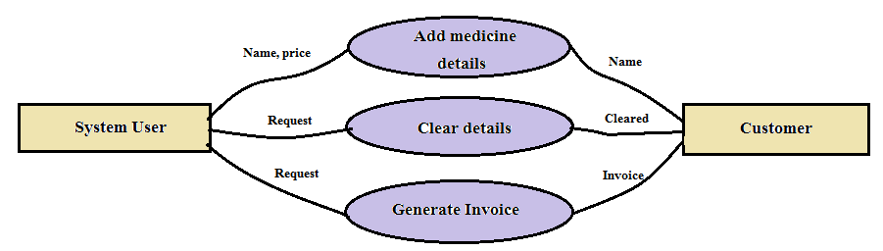

Fig 3.1: DFD [4]

3.5 E-R Diagram

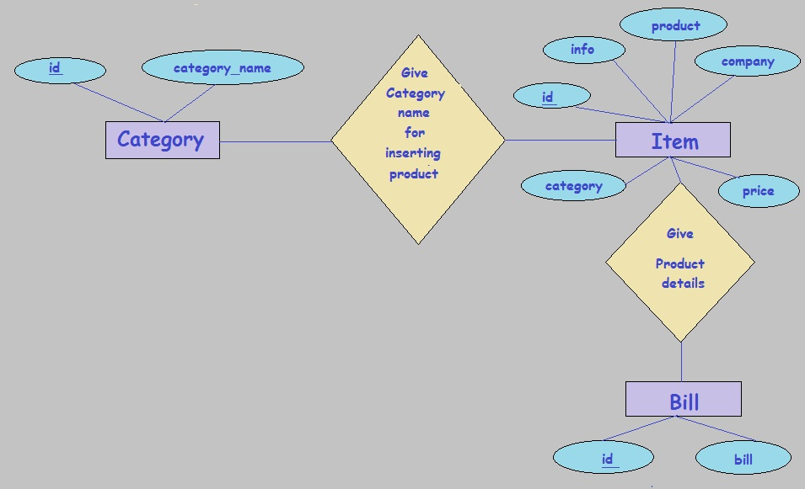

Fig 3.2: E-R Diagram [5]

CHAPTER FOUR
Implementation & Testing

Implementation is the stage in the project where the theoretical design is turned into a working system. The implementation phase constructs, installs and operates the new system. The most crucial stage in achieving a new successful system is that it will work efficiently and effectively.

4.1 Cover page Form

- It is the opening window of our system. It has only a button “Next” is used to go to the next form.

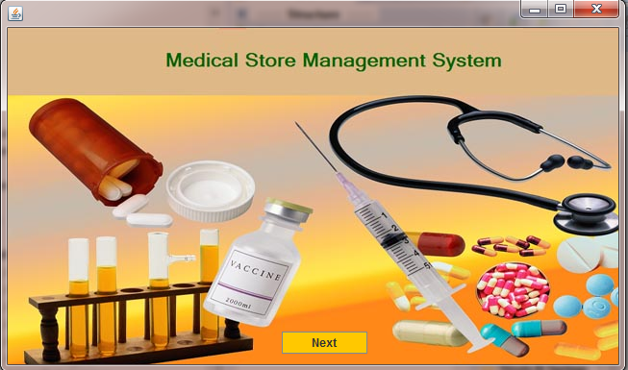

Fig 4.1: Cover page Form

  - Select Form

- Select form offer us two options for selecting admin or user for conducting the medical store.

1. Admin

2. User

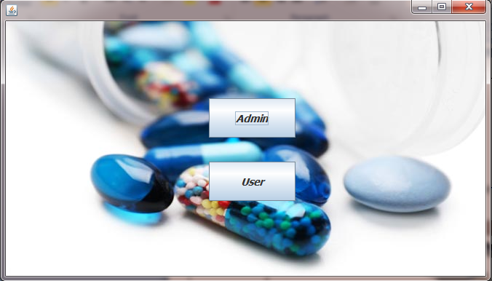

Fig 4.2: Select Form

4.2.1.1 Login Form

- This login Form is made For Security purpose. So only Authenticated User only Access in to the Project.

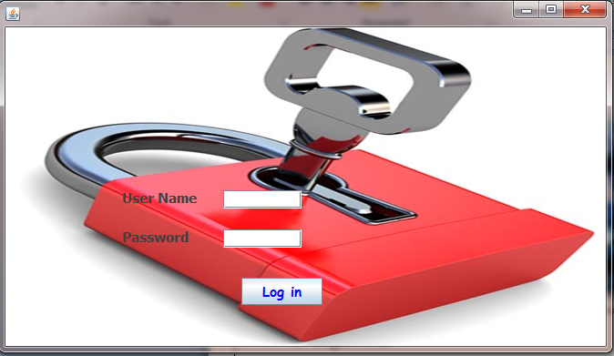

Fig 4.3: Login Form

- In ‘Login Form’ there is two fields- one for ‘User name’ and other for ‘Password’ and a ‘Login’ button.
- When the wrong user name and password are entered by the user the following message will be shown.

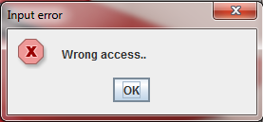

Fig 4.4: Error message box

- When the correct user name and password are entered by the user, he can access to the system and ‘Menu Form’ will open.

4.2.1.2 Menu Form

The picture is given bellow is the menu form of our system. There are nine buttons here.
- Here ‘Home’ button is used to go to ‘Select Form’ to choose Admin or Football.
- ‘Add Category’ button is used to go to ‘Add Category’ window to add category.
- ‘Update Category’ button is used to go to ‘Update Category’ window to update category.
- ‘Delete Category’ button is used to go to ‘Delete Category’ window to delete category.
- ‘Add Product’ button is used to go to ‘Add Product’ window to insert product.
- ‘Update Product’ button is used to go to ‘Update Product’ window to update product information.
- ‘Delete Product’ button is used to go to ‘Add Product’ window to delete product.
- ‘Product List’ button is used to go to ‘Product List’ window to show the list of products in our stock.
- ‘Order list’ button is used to go to ‘Product List’ window to show the invoice list of sale.

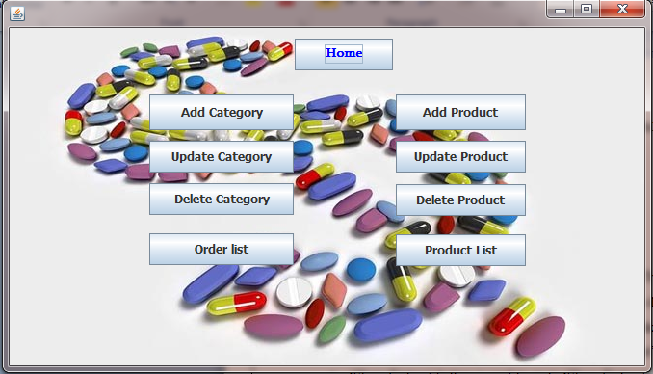

Fig 4.5: Menu Form

4.2.1.3 Add Category Form

- In this form we add the category under which products will be enlisted.

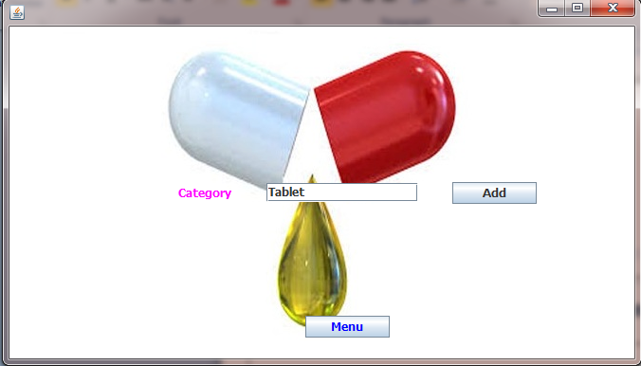

Fig 4.6: Add Category Form

- Press ‘Add’ button to add category.
- Press ‘Ok’ button to exit from this message.
- Here ‘Menu’ button is used to go to ‘Menu’ window.

4.2.1.4 Update Category Form

- It is used to update the category name.

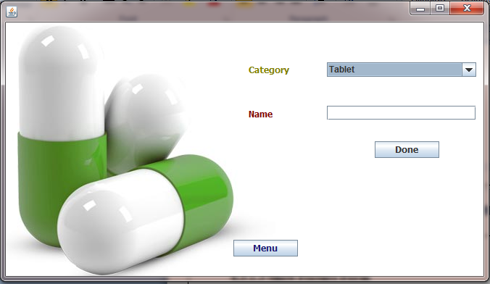

Fig 4.7: Update Category Form

- When no value is entered by the user the following message will be shown.

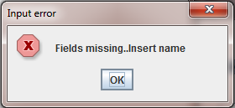

Fig 4.8: Message Box

- ‘Done’ button is used to update the info.
- ‘Menu’ button is used to go to ‘Menu’ window.

4.2.1.5 Delete Category Form

- It is used to delete category.

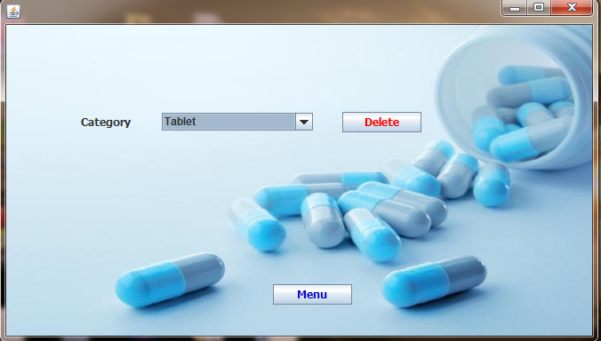

Fig 4.9: Delete Category Form

- After pressing the delete button ,

- ‘Menu’ button is used to go to ‘Menu’ window.

4.2.1.6 Add Product Form

- It is used to add product.

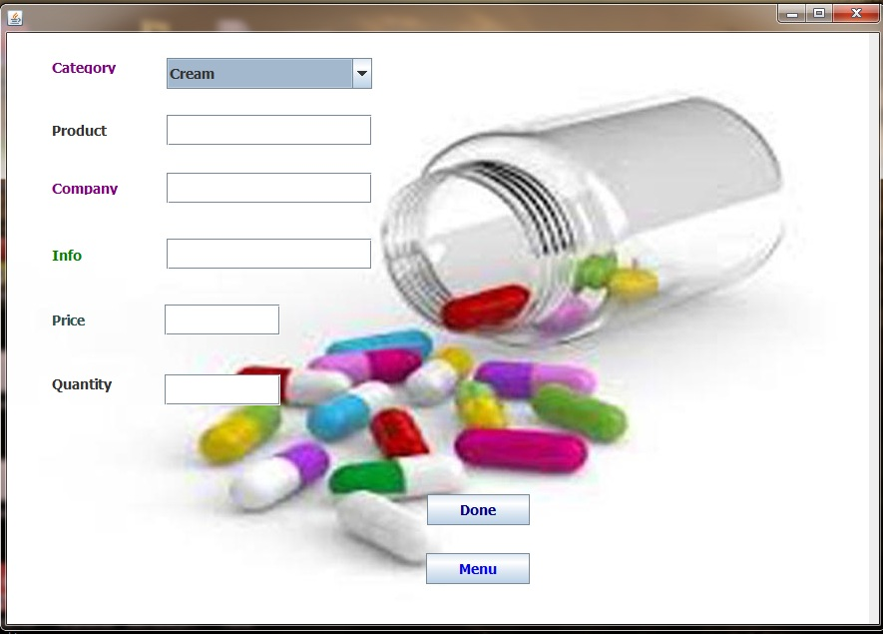

Fig 4.10: Add Product Form

- After pressing the ‘Done’ button ,

- ‘Menu’ button is used to go to ‘Menu’ window.

4.2.1.7 Update Product Form

It is used to update product info

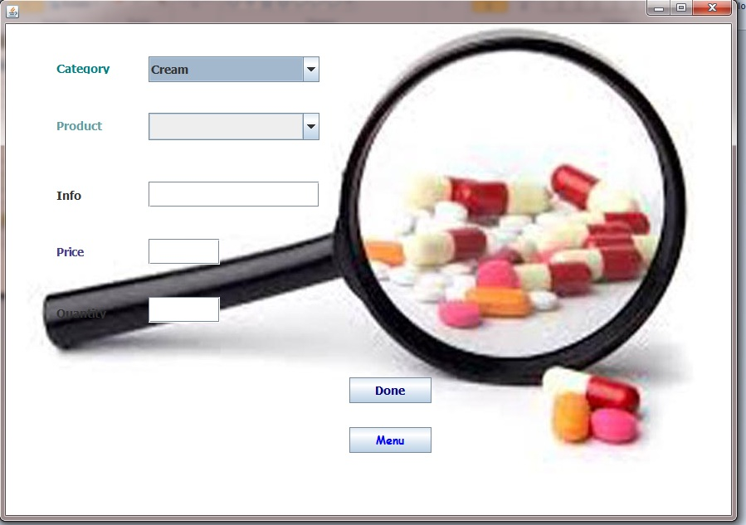

Fig 4.11: Update Product Form

- Press ‘Ok’ button to exit from this message.
- ‘Menu’ button is used to go to ‘Menu’ window

4.2.1.8 Delete Product Form

- It is used to delete the product.

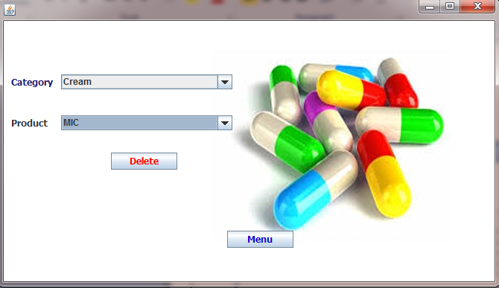

Fig 4.12: Delete Product Form

- When “Delete” button is pressed, product is deleted.
- Press ‘Ok’ button to exit from this message.
- ‘Menu’ button is used to go to ‘Menu’ window.

4.2.1.9 Product List Form

- In this form we see the product list in our stock category wise.

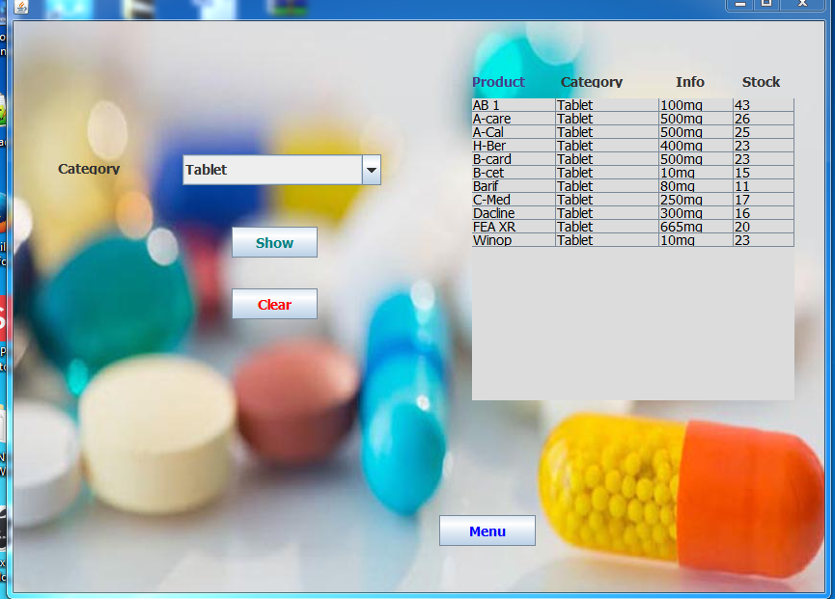

Fig 4.13: Product List Form

- ‘Show’ button is used to show the information in table.
- ‘Clear’ button is used to clear the table.
- ‘Menu’ button is used to go to ‘Menu’ window.

4.2.1.10 Order List Form

- In this form we can see all the invoice id and corresponding bill amount according to dates.

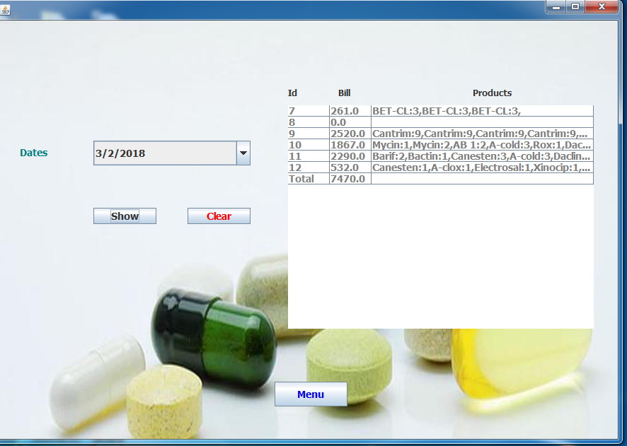

Fig 4.14: Order List Form

- ‘Menu’ button is used to go to ‘Menu’ window.

4.2.2.1 User Login Form

- This login Form is made For Security purpose. So only Authenticated User only Access in to the Project.

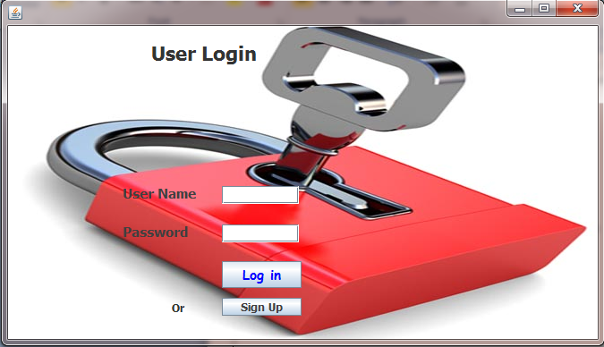

Fig 4.15: Login Form

- In ‘Login Form’ there is two fields- one for ‘User name’ and other for ‘Password’ and a ‘Login’ button.
- When the wrong user name and password are entered by the user the following message will be shown.

Fig 4.16: Error message box

- When the correct user name and password are entered by the user, he can access to the system and ‘Menu Form’ will open.

4.2.2.2 Signup Form

- ‘Done’ button is used to confirm the insertion.
- ‘Login’ button is used to go back to the login form.

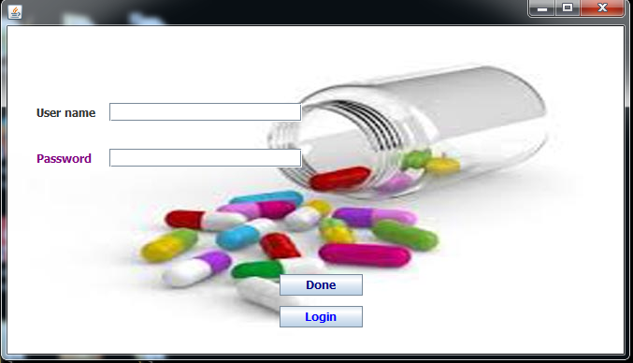

Fig 4.17: Signup Form

4.2.2.3 Order Form

- This from is used to sell product and produce invoice. Product can select from their category.
- ‘Cancel Any Product’ button is used to delete any product from order list.
- ‘Order’ button is used to order.
- ‘Reset’ button is used to clear the order list.
- ‘Print’ button is used to print the order list.

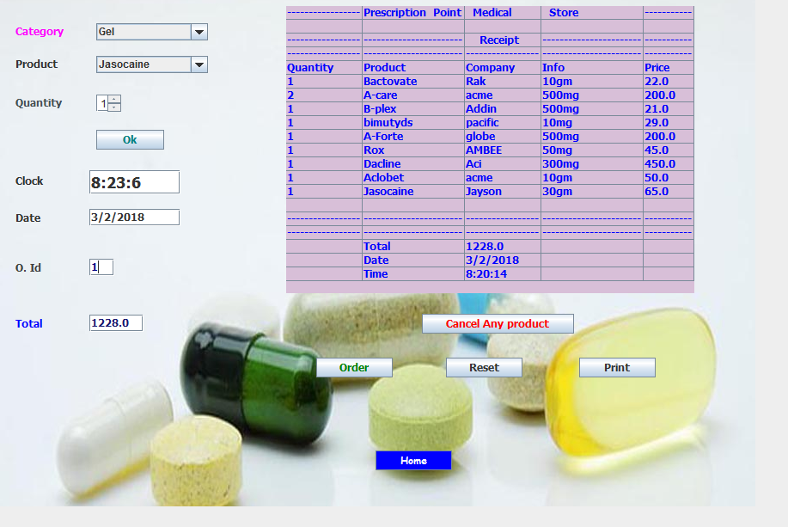

Fig 4.18: Order Form

CHAPTER FIVE
Comparison

I want to provide a desktop based application for medical store. Normally, almost all medical store perform their calculation manually and my application will help them to work digitally and they can record their store details in database, also can print their invoice which is to given to customer.

CHAPTER Six
Conclusion and Future work

6.1 Conclusion

This project has developed mainly for a medical store which is managed by a manager and his staffs. The main features of this project that the any staff can sell product easily and update info in database. But only manager can handle the stock information.

6.2 Future Work

- I am interested to add more features which make the project more convenient to its users such as introducing barcode reader to read product details quickly.
- I am also interested to make the android version of this project.

List of References

[1] Project attendence managemnt system Pdf , last downloaded: 10:20pm, 24/10/2016
[2] http://en.wikipedia.org/wiki/Eclipse_(software), last accessed: 9:30pm, 25/10/2016
[3] JAVA The Complete Reference-Herbert Schield, fourth edition, pp. 12-13
[4] System Analysis and Design – Elias M.Awad, second edition, pp. 170-175
[5] Database System Concepts-Abraham Silberschatz , S.Sudarshan , Henry F.Korth, fifth edition, pp. 201-240

